H.T No
Regulations:
A20

Sreenidhi Institute of Science and Technology
(An Autonomous Institution)
Code No: 8B103 Date: 09-Feb-2024 (AN)

B.Tech I-Year I- Semester External Examination, Jan/Feb-2024 (Supplementary)
ENGINEERING MECHANICS(ME)

Time: 3 Hours Max.Marks:70

Note: a) No additional answer sheets will be provided.
b) All sub-parts of a question must be answered at one place only, otherwise it will not be valued.
c) Missing data can be assumed suitably.
Bloom's Cognitive Levels of Learning (BCLL)

Remember | L1 | Apply | L3 | Evaluate | L5
Understand | L2 | Analyze | L4 | Create | L6

Part - A Max.Marks:20

Answer all QUESTIONS.

 |  | BCLL | CO(s) | Marks
1 | State the general algebraic conditions of equilibrium for concurrent-coplanar forces and concurrent - non-coplanar forces. | L1 | CO1 | [2M]
2 | Define and explain the following  (i) Coefficient of friction (ii) Limiting friction | L1 | CO2 | [2M]
3 | Define the terms : moment of inertia and radius of gyration. | L1 | CO3 | [2M]
4 | State and explain transfer formula for mass moment of inertia. | L1 | CO4 | [2M]
5 | Differentiate between kinetic energy and potential energy | L1 | CO5 | [2M]
6 | What is work-energy principle for rotation bodies? | L1 | CO6 | [2M]
7 | Explain the differences between coefficient of friction and angle of friction | L1 | CO1 | [2M]
8 | State the theorems of Pappus and Guldinus | L1 | CO3 | [2M]
9 | What is the principle of conservation of energy? | L1 | CO5 | [2M]
10 | State and explain Lami’s theorem. | L1 | CO6 | [2M]

Part – B Max.Marks:50
ANSWER ANY FIVE QUESTIONS. EACH QUESTION CARRIES 10 MARKS.

 |  |  | BCLL | CO(s) | Marks
11. | a) | What is Newton’s first law of motion and law of transmissibility of forces? | L1 | CO1 | [5M]
 | b) | Find the magnitude and direction of the resultant force. Also find the position of the resultant force from point P of the bar PS (Figure 1).  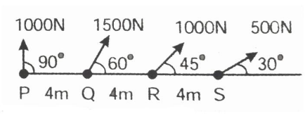 | L3 | CO1 | [5M]
12. |  | The truss in Fig 2. is pinned to the wall at point F, and supported by a roller at point C. Calculate the force (tension or compression) in members BC, BE, and DE .  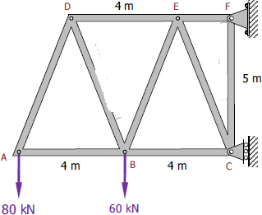 | L3 | CO2 | [10M]
13. |  | Find the moment of inertia of the shaded area shown in the figure 3 about the edge AB.  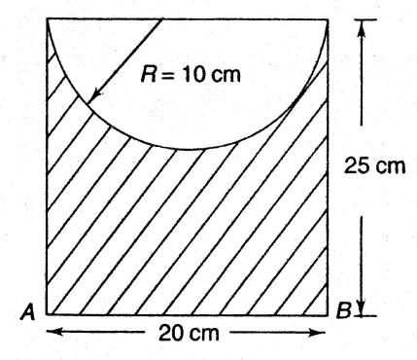 | L3 | CO3 | [10M]
14. | a) | Determine the mass moment of inertia of a uniform ring having radius ‘R’ and thickness ‘t. | L3 | CO4 | [5M]
 | b) | Determine the mass moment of inertia of a solid cone of height ‘h’ and base radius ‘r’ about its axis of rotation. | L3 | CO4 | [5M]
15. |  | A projectile is aimed at a mark on the horizontal plane through the point of projection. It falls 12 metres short when the angle of projection is 15°. while it overshoots the mark by 24 metres when the same angle is 45°. Find the angle of projection to hit the mark. Assume no air resistance. | L3 | CO5 | [10M]
16. |  | Two bodies A and B of mass 80 kg and 20 kg are connected by a thread and move along a rough horizontal plane under the action of a force 400 N applied to the first body of mass 80 kg as shown in Figure 4. The coefficient of friction between the sliding surfaces of the bodies and the plane is 0.3. Determine the acceleration of the two bodies and the tension in the thread, using D' Alembert‟s principle.  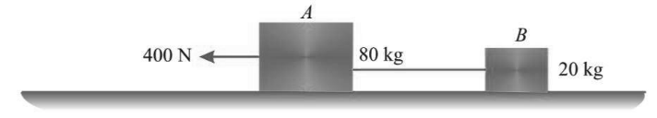 | L3 | CO6 | [10M]
17. | a) | Define the terms (i) moment of a force (ii) Free Body Diagram | L1 | CO1 | [4M]
 | b) | Write down the expression for the centroid of a quarter circle. | L1 | CO2 | [3M]
 | c) | Give any two laws of friction. | L1 | CO3 | [3M]
18. | a) | Differentiate between mass and area moment of inertia | L1 | CO4 | [4M]
 | b) | Differentiate between uniform and non uniform acceleration. | L1 | CO5 | [3M]
 | c) | Derive the equations for Motion with uniform acceleration. | L1 | CO6 | [3M]
-- 00 -- 00 –

